AZURE VIRTUAL DESKTOP

* Azure Virtual Desktop is a desktop and app virtualization service that runs on Microsoft Azure.
* Azure Virtual Desktop can be accessed from any device such as Windows, Mac, iOS, Android, and Linux.



**Deliver Windows 11 and Windows 10 desktops**

* Provide employees the best virtualized experience with the only solution fully optimized for Windows 11, Windows 10, and Microsoft 365.
* Choose the right Azure virtual machine (VM) to optimize performance and leverage the Windows 10 and Windows 11 multi-session advantage on Azure to run multiple concurrent user sessions and save costs.



**Built-in intelligent security**

* Help keep your applications and data secure and compliant with security capabilities that can proactively detect threats and take remedial action.

**Deploy and scale in minutes**

* Simplify deployment and management of your infrastructure and scale quickly based on your business needs.



**Reduce cost using existing licenses**

* Use existing eligible licenses to reduce costs with a modern cloud-based virtual desktop infrastructure (VDI) and pay only for what you use.

**Empowering remote work**

* An increasing number of companies are implementing VDI for remote workers because virtual desktops are easier to deploy and update from a centralised location.



**Enabling task-based or shift work**

* Organisations such as call centres or public computer labs that have a large number of users who need the same software to perform limited tasks find non-persistent VDI to be particularly well suited to their use case.



**Bring Your Own Device**

* VDI is an ideal solution for organisations with BYOD policies as it allows the use of a wider range of devices. It also helps with data security because data lives on the server and is kept off the client devices.

**LICENSING**

|  |  |
| --- | --- |
| **Operating System** | **License Entitlement:** |
| **Windows 10 Enterprise** | * Microsoft 365 - Business Premium, E3, E5, F3, A3, A5. * Windows Enterprise E3, E5 and Education A3, A5 and VDA |
| **Windows 10 Enterprise multi session** |
| **Windows 11 Enterprise** |
| **Windows 11 Enterprise multi-session** |

|  |  |
| --- | --- |
| **Windows Server 2022** | * Remote Desktop Services (RDS) Client Access License (CAL) with Software Assurance (per-user or per-device), or RDS User Subscription Licenses. |
| **Windows Server 2019** |
| **Windows Server 2016** |
| **Windows Server 2012 R2** |

**HOST POOLS**

* A host pool is a collection of Azure virtual machines that register to Azure Virtual Desktop as session hosts when you run the Azure Virtual Desktop agent.
* All session host virtual machines in a host pool should be sourced from the same image for a consistent user experience.

* **Personal** where each session host is assigned to an individual user. Personal host pools provide dedicated desktops to end-users that optimize environments for performance and data separation.

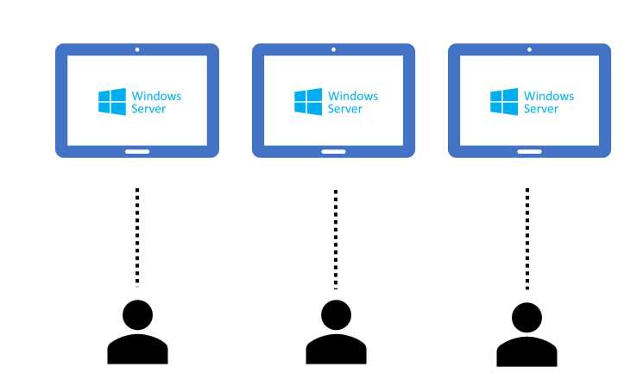

**Personal**

* **Pooled** where user sessions can be load balanced to any session host in the host pool. There can be multiple different users on a single session host at the same time. Pooled host pools provide a shared remote experience to end-users, which ensures lower costs and greater efficiency.

**Pooled**

**IDENTITY**

* Azure Virtual Desktop is a service integrated into Azure Active Directory, so basically when I assign a desktop or an app to a specific group of users,
* I’m using Azure Active Directory groups and Azure Active Directory users.
* If my Azure Virtual Desktop solution is cloud only, I can use cloud-only groups containing cloud-only users to assign resources that are working inside Azure virtual machines that are joined only to Azure Active Directory.

**FSLOGIX**

* FSLogix enhances and enables a consistent experience for Windows user profiles in virtual desktop computing environments.
* FSLogix isn't limited to virtual desktop environments but could be used on physical desktops where a more portable user experience is desired.
* The main purpose of FSLogix is profile separation. It’s possible to maintain the user data and preferences outside the device and store everything in a VHD/VHDX file that can be attached at the time of login.
* The FSLogix installed inside each virtual machine, the user profile is maintained in a share inside Azure (for example in an Azure Files file share), and it’s attached at the time of login.
* Let’s pretend that the first day of usage, the user is redirected to the first virtual machine of our pool. So, the VHD/VHDX file that contains their user profile is attached to virtual machine 1.

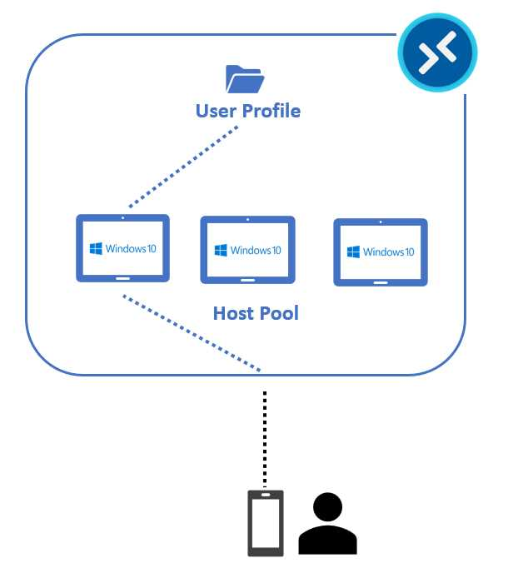

**FSLogix User Profile Attach on Day 1**

* On the second day, the user requests the same service, but now the system is assigning the third virtual machine of the pool, so the VHD/VHDX file is now mounted into the virtual machine 3 file system.

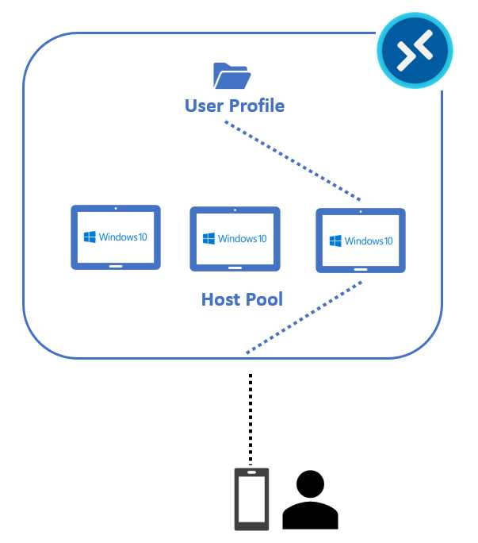

**FSLogix User Profile Attach on Day 2**

**FSLogix has some advantages:**

* + The agent is very lightweight.
  + The cache of Office and the index of Windows are preserved inside the user profile, so when I’m logging into a new virtual machine, I don’t have to wait for the build of these files.
  + It can be simply managed using group policies of registry keys.

**Storage for maintaining profile:**

* + Azure File Storage
  + Azure NetApp
  + Storage Spaces

**FOURTH DIMENSION TECHNOLOGIES PVT LTD**

#21, Dignity Center,3rd Floor, Abdul Razack Street, Saidapet, Chennai-600 015.

* Lan Line: [+91 44 4306 5400](https://www.fourdtech.com/say-hello/) E-Mail : [4d@fourdtech.co.in](https://www.fourdtech.com/say-hello/)

